Github personal access token:
0f9f6829e0e4a0690f5bf4d503531fe372cac984

Jenkins-github commit status configuration

In the meanwhile the UI of Jenkins and GitHub has changed a bit and it took me a while to figure out how to configure Jenkins now correctly. The explanation here is based on Jenkins version 2.121.1.
I also assume that you have already configured your Jenkins Job be triggered by a webhook or by polling. Those are the steps that I have taken to get it working:
- Configure Github: Create Personal Access Token with OAuth Scope repo:status
- Configure Jenkins: Configure System and add the OAuth Secret as a GitHub Server - use Secret Text as an authentication method to put the OAuth Secret in there.
- Configure your Jenkins Job: Add Set GitHub commit status as Post-build action. Set the Status Result to One of the default messages and statuses.
- Check your result on GitHub: Check if you get the build status and build execution duration on your GitHub commit.

Configure Github
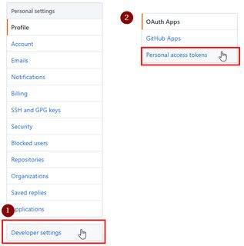

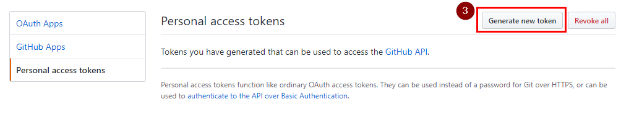

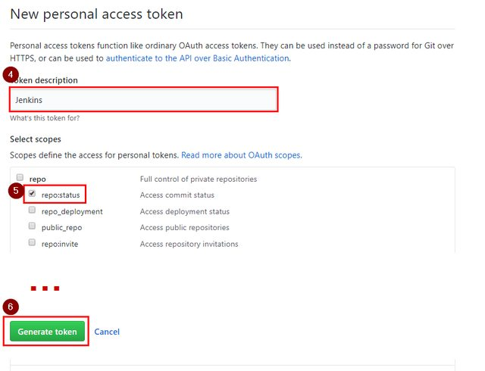

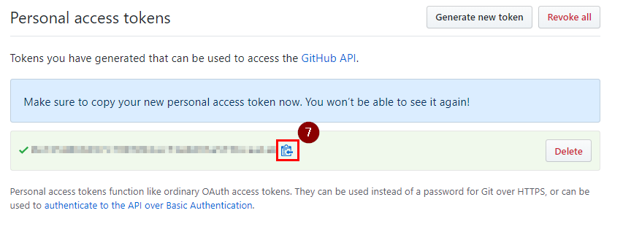

Configure Jenkins
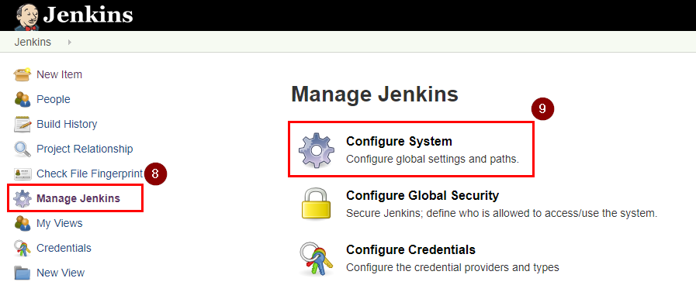

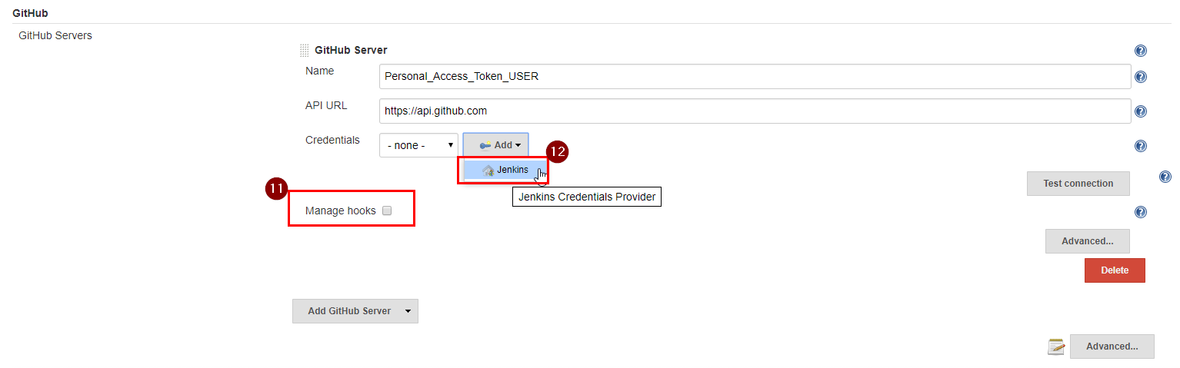

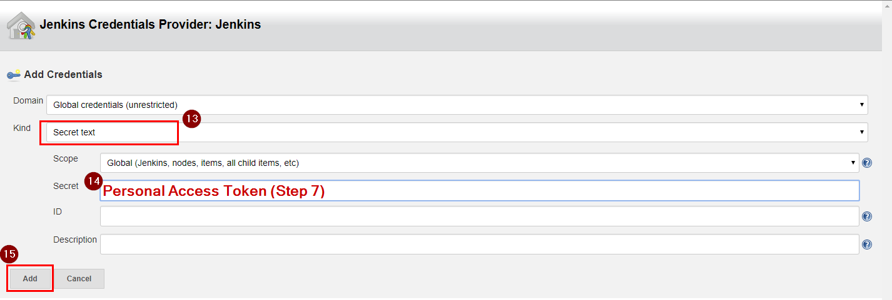

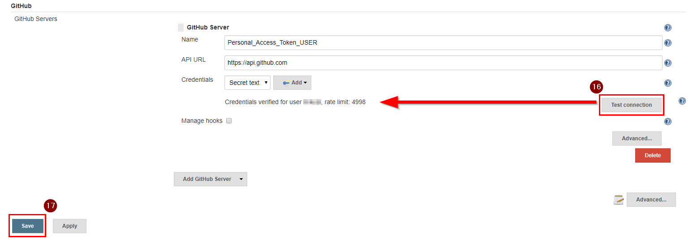

Configure Jenkins Job
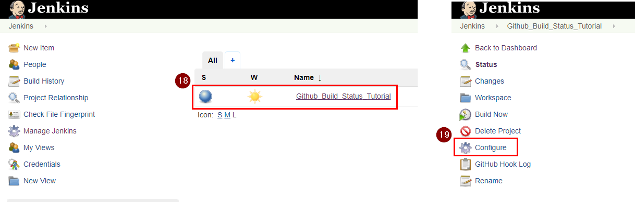

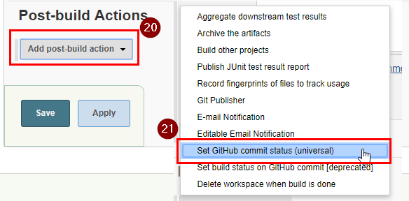

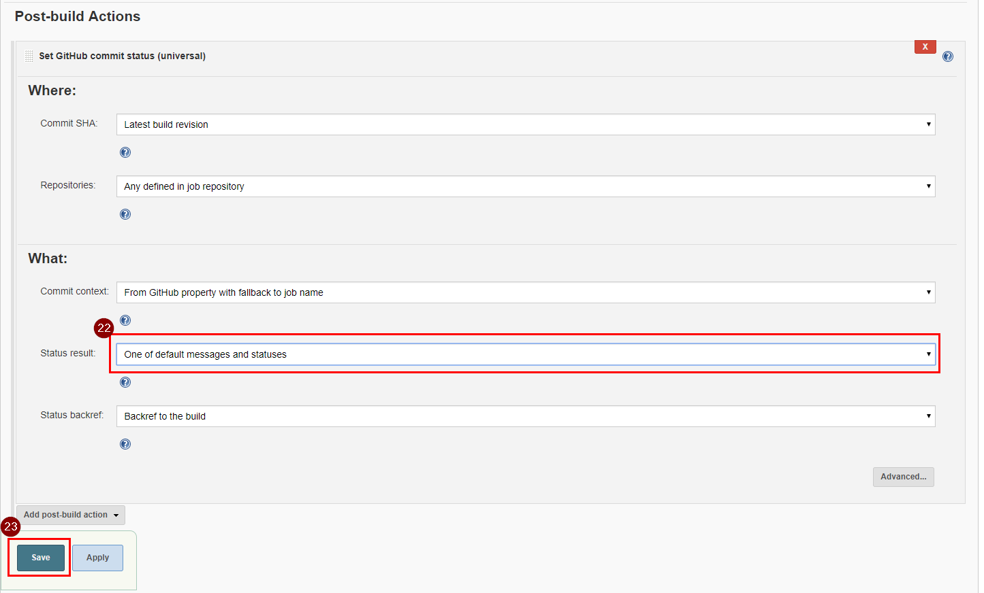

Result
You will now see the status for your commits and branches:
